Indications of Intimate Association

I dated a girl once (one time!). I told her innocently that I didn't care, ever really, what she did all day. Or what her favorite color was. Or other information you might find in a 7th grade chain email questionnaire about yourself. I wasn't trying to be an ass (innate born ability?), but it took me a moment to actually explain myself. I don't care what your favorite color is unless yellow reminds you of the sun dress your mom used to wear when she would take you to the park before she died. There's a certain amount of information that I find irrelevant. If I had one wish, it would be for everyone else to find that information useless as well.

There's a certain amount of all information that I regard as important if someone I regard as important regards that information as important. But if there was a friend customer survey that I could choose which extemporaneous information would be eradicated from associative communication, this is the sort of knowledge we could all do without.

If we could scale or graph indicators of the closeness to which we feel to people, near to the top would be the amount of time known. At least this is one of the prime perceived notions that lead people to evaluate their relationships as 'close'. I don't get it really. There's a billion variables here that completely leave me baffled by this concept. A billion. Literally!!!!!
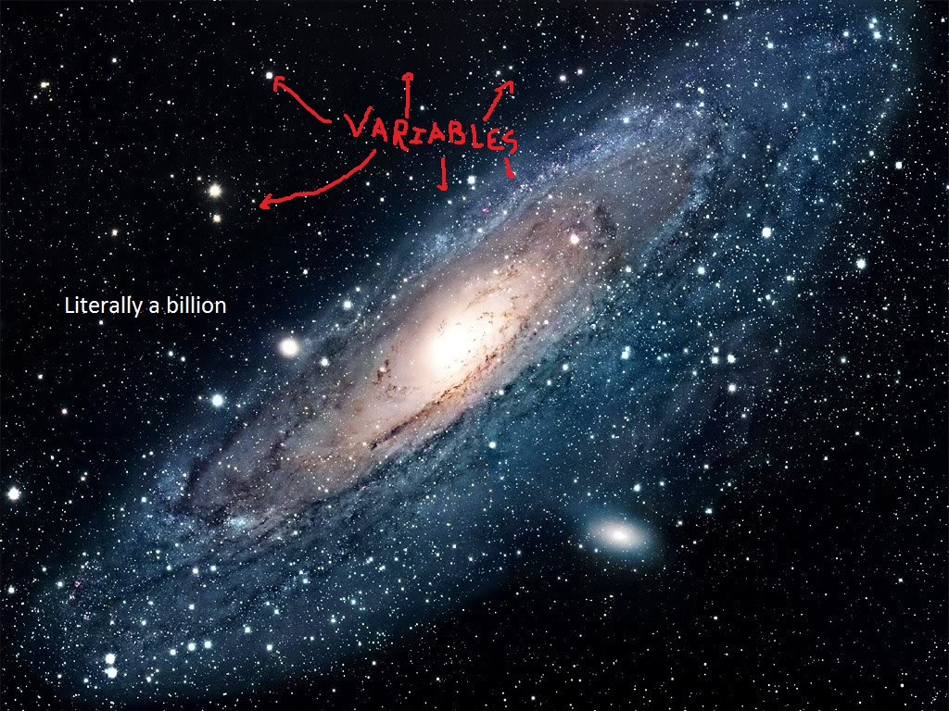
AFFINITY FLUX

Individuals change over time. I have a childhood friend that I was very close to at one point. When I talk to this friend now, he'll say things like

“You know what your problem is right?”

and I'll try and find a way to force an asthma attack so I don't have to hear it.

“It's all about the chase for you”

That's what his knowledge of me once told him. I would have disagreed then and adamantly digress now. As we change, we disconnect on those elements from those who have no knowledge of these specific transformations. It weakens are overall connection. The core identity of most people does not diverge much from it's concrete beginnings. But our relational points do; the network of attachments that bridge between comparable commonalities and magnetic-like diametric proclivities are foundational and mercurial. Therefore, they are in need of constant renewal, adjustment, or stabilization. Affinity Flux. Nobody wants to flux with their friends and in romantics, flux carefully and together. With protection.

Not fluxing together

Time is not such an indicative factor of intimate rapport. Quantity vs quality and all that right? Time is an intermediary, a currency. There's a certain inveterate, desperate consequence to all sequential interactions in relationships. Digression or progression, interminable.

